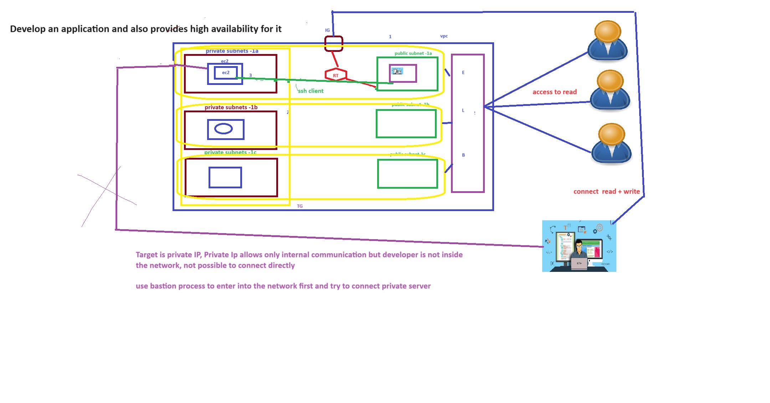

From above image horizontal yellow lines are nodes.

Node will be created zone level

Public instance not required to configure load balancer only public subnets required.

For target group private instance required

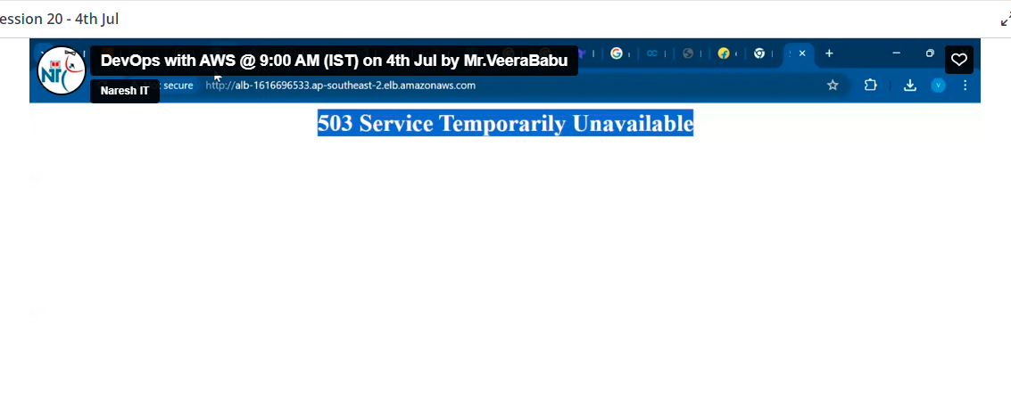

this is because az target are not selected in ALB

no node is formed for TG from ALB for AZ’s